Project Report

Tracing the Growth of the Global Community: A Population Forecasting Analysis

1. INTRODUCTION
   1. Overview

The world’s population is more than three times larger than it was in the mid-twentieth century. The global human population reached 8.0 billion in mid-November 2022 from an estimated 2.5 billion people in 1950, adding 1 billion people since 2010 and 2 billion since 1998. The world’s population is expected to increase by nearly 2 billion persons in the next 30 years, from the current 8 billion to 9.7 billion in 2050 and could peak at nearly 10.4 billion in the mid-2080s. This dramatic growth has been driven largely by increasing numbers of people surviving to reproductive age, the gradual increase in human lifespan, increasing urbanization, and accelerating migration. Major changes in fertility rate have accompanied this growth. These trends will have far-reaching implications for generations to come.

* 1. Purpose

The purpose of tracing the growth of the global community is to gain a deeper understanding of the social, cultural, economic, and political dynamics that have shaped our world over time. By studying the evolution of the global community, we can better understand the historical context of current events, identify trends and patterns, and anticipate future developments.

Tracing the growth of the global community can also help us appreciate the diversity of human experience and recognize the commonalities that unite us. It can foster a sense of global citizenship and encourage collaboration and cooperation across borders to address common challenges.

Furthermore, studying the growth of the global community can inform policies and decision-making at the national and international level, helping to promote peace, stability, and prosperity for all.

It can also inspire innovation and creativity, as people from different cultures and backgrounds come together to share ideas and knowledge.

Overall, tracing the growth of the global community can provide us with valuable insights into the complexity and interconnectedness of our world, helping us to build a more inclusive, equitable, and sustainable future.

1. Problem Definition & Design Thinking

2.1 Empathy Map

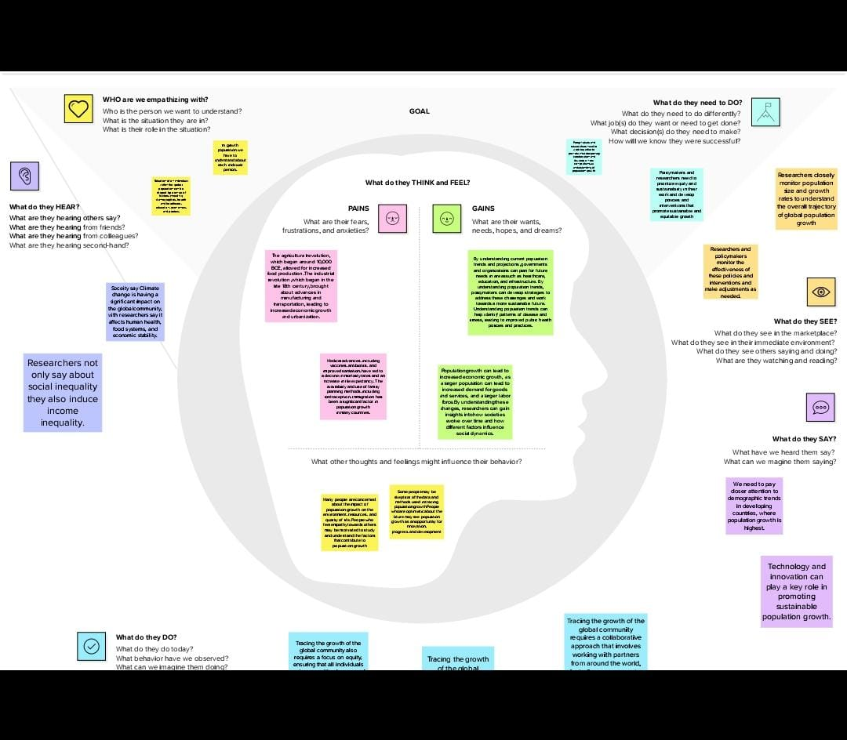

2.2 Ideation & Brainstorming Map

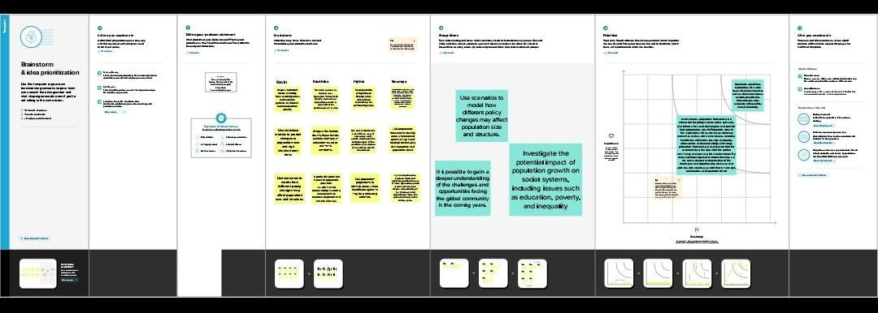

1. RESULT

Activity & Screenshot

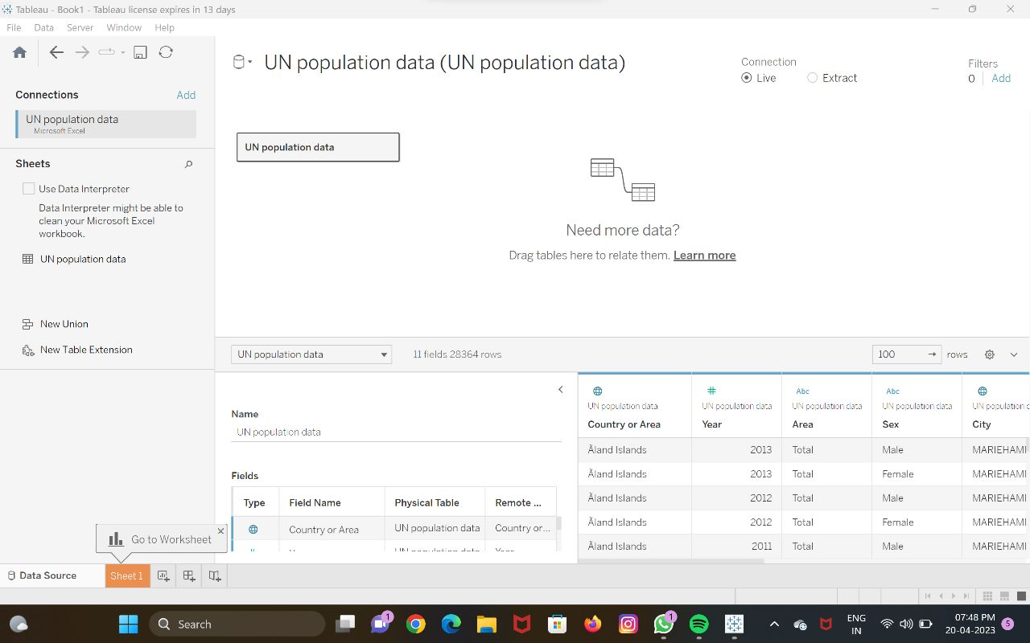

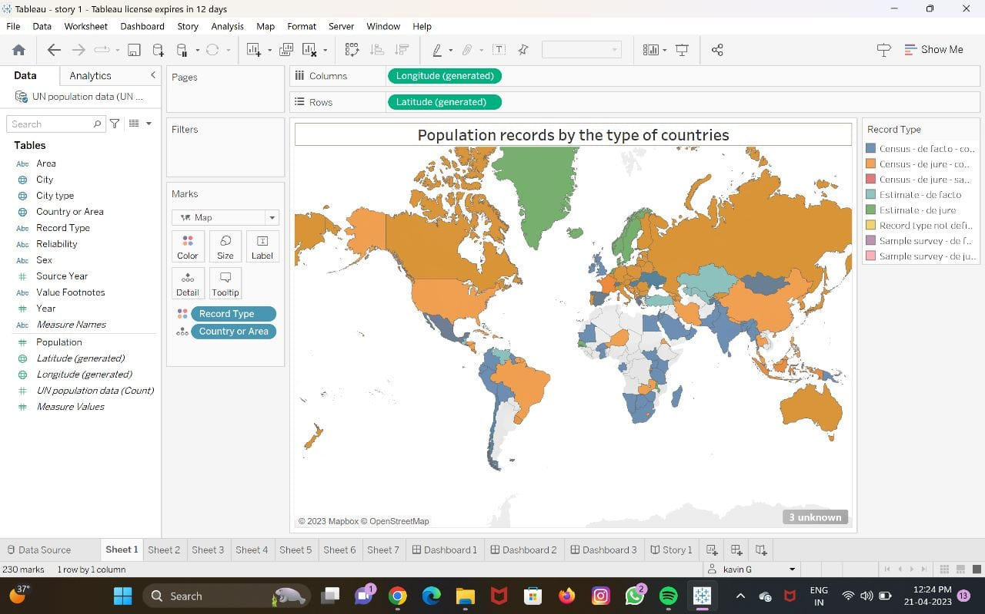

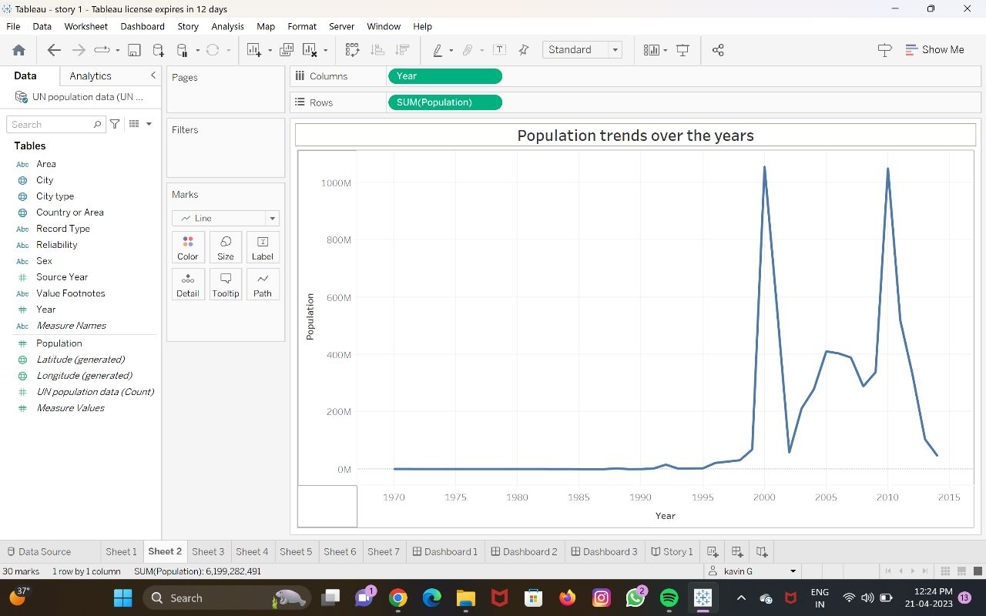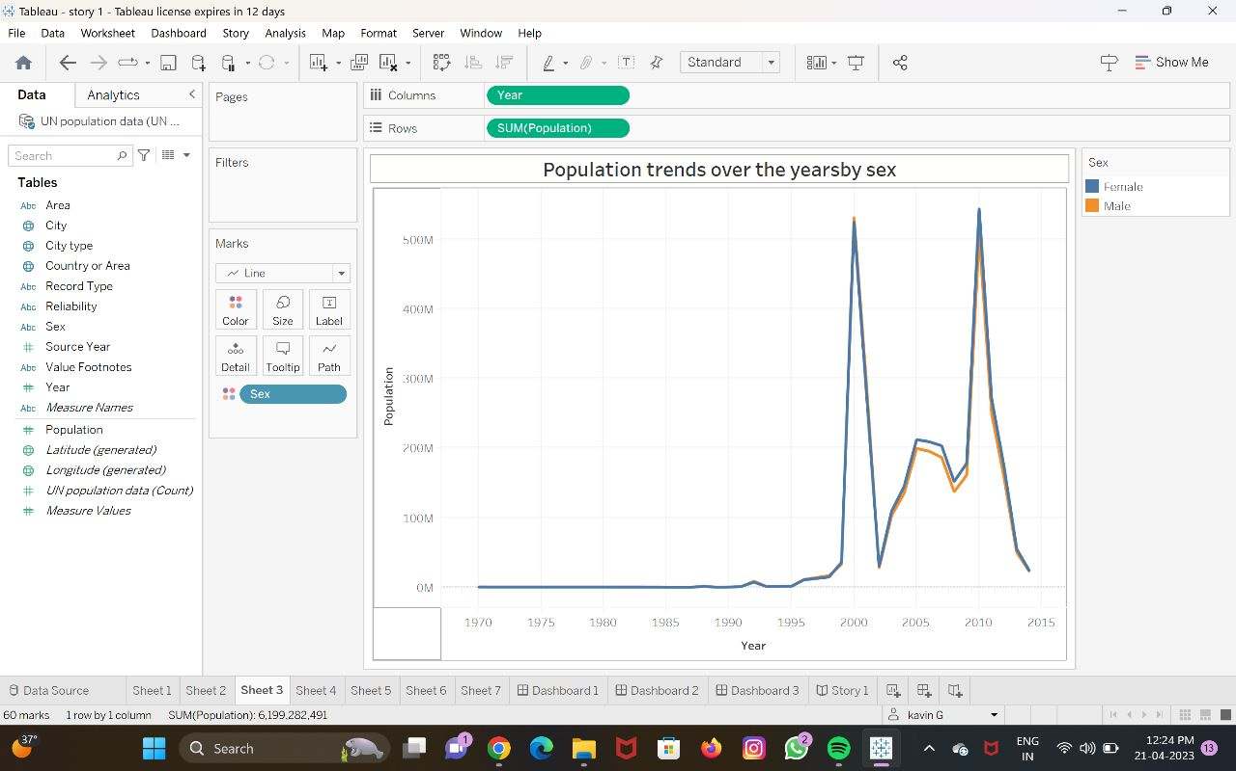

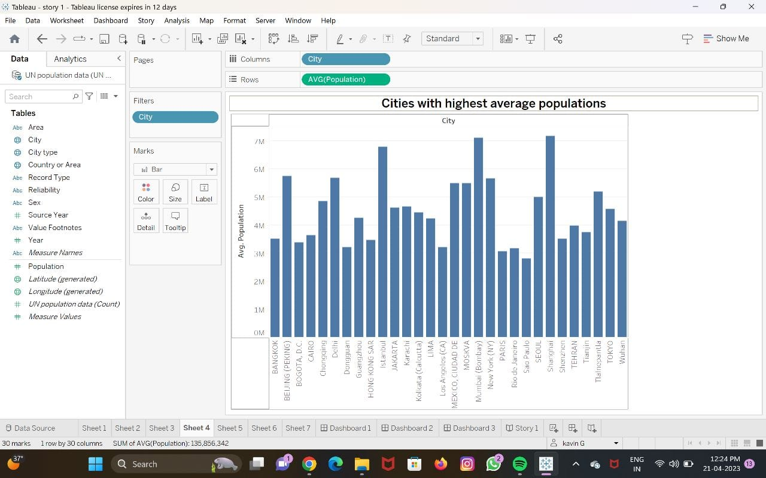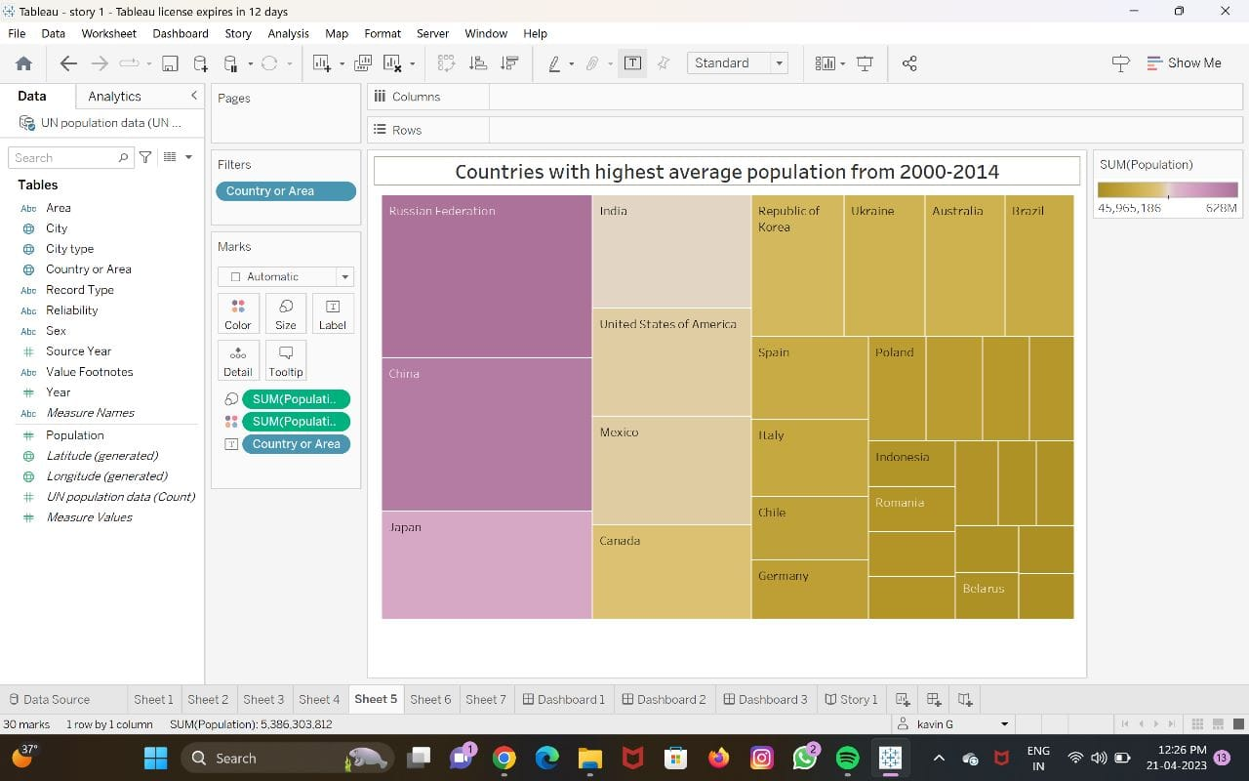

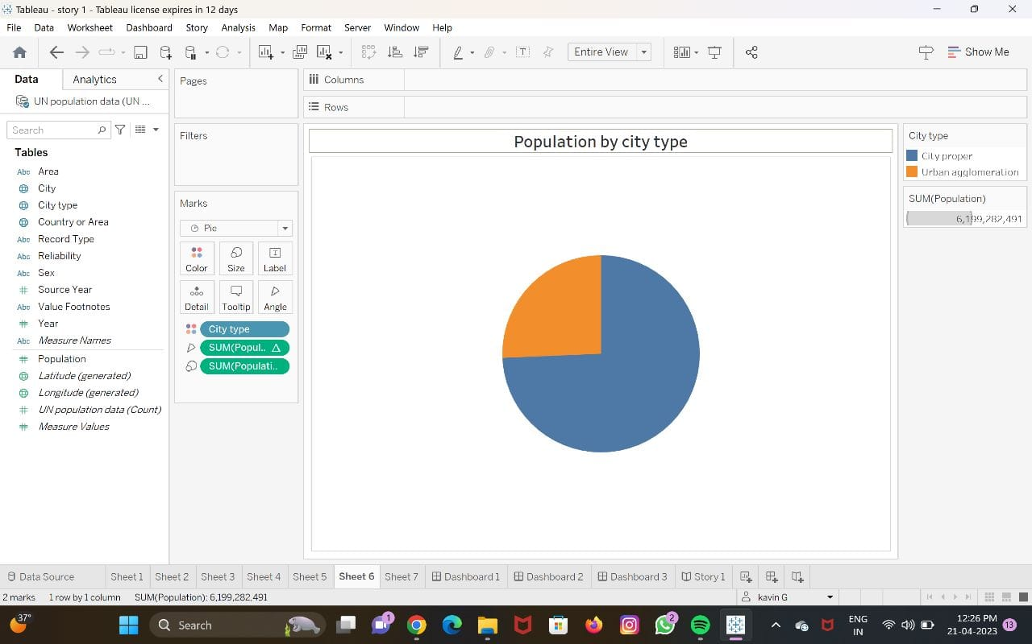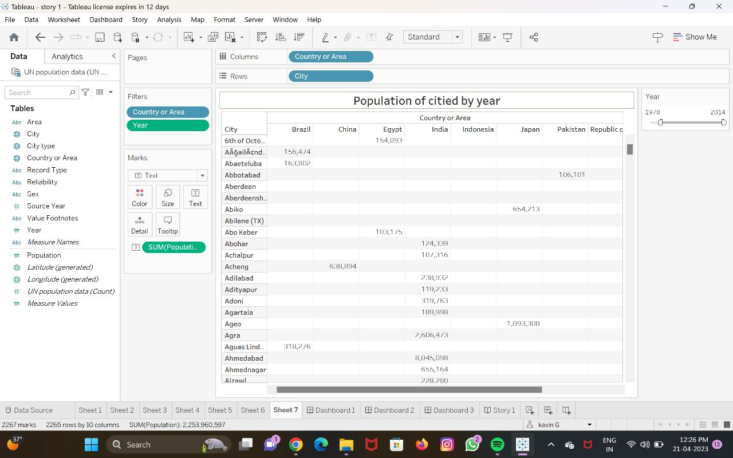

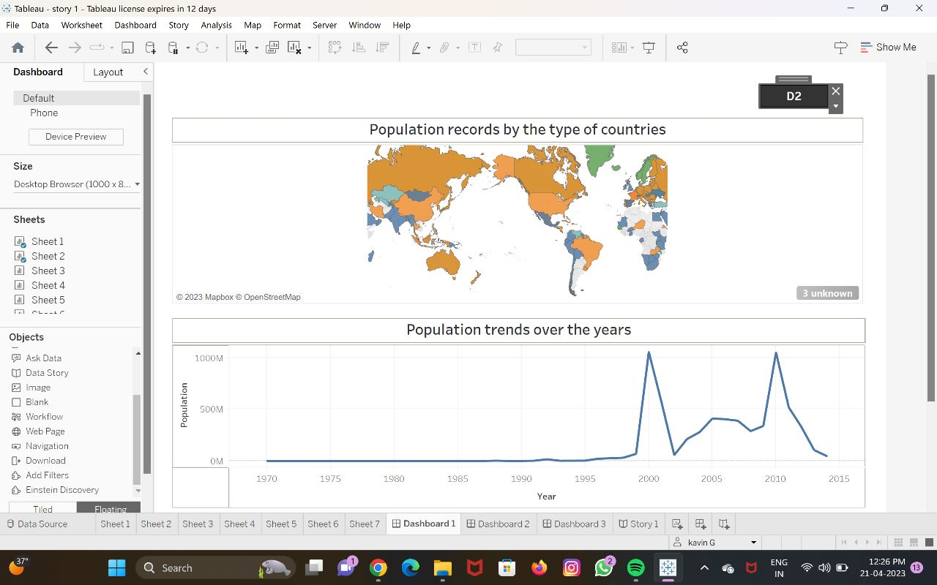

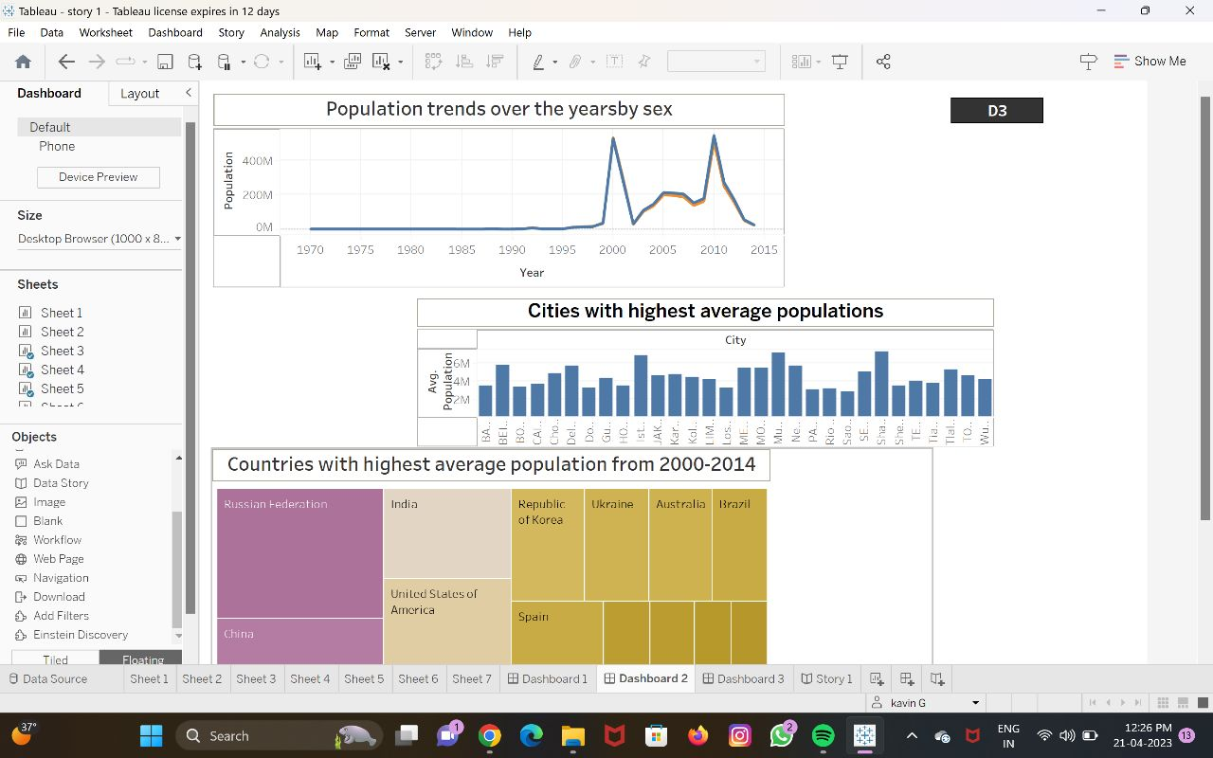

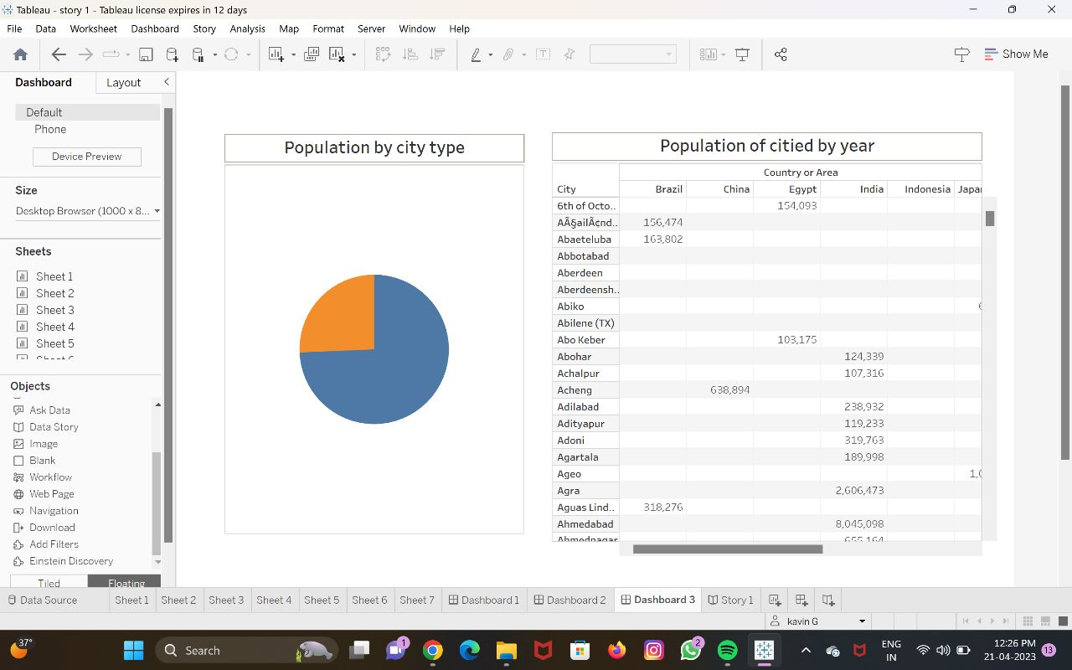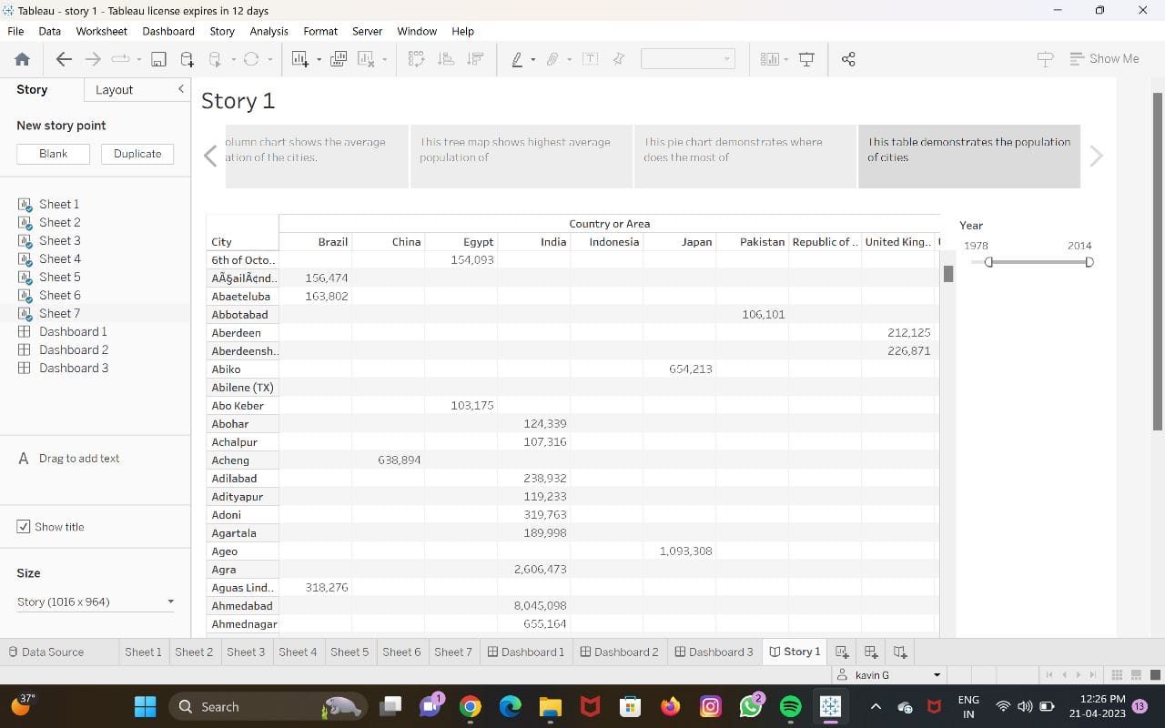

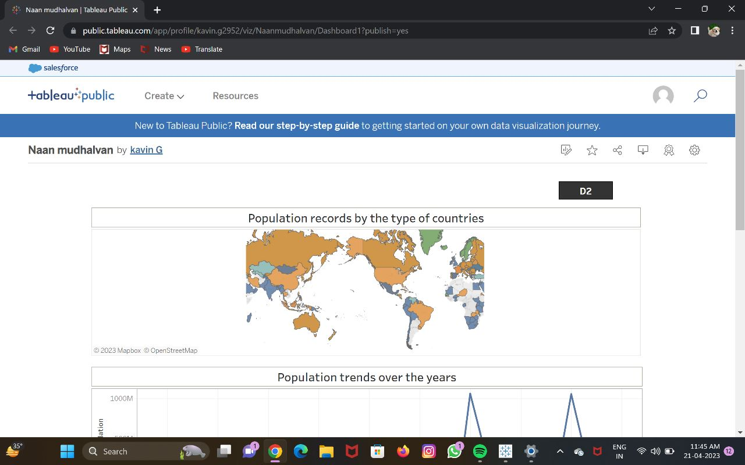

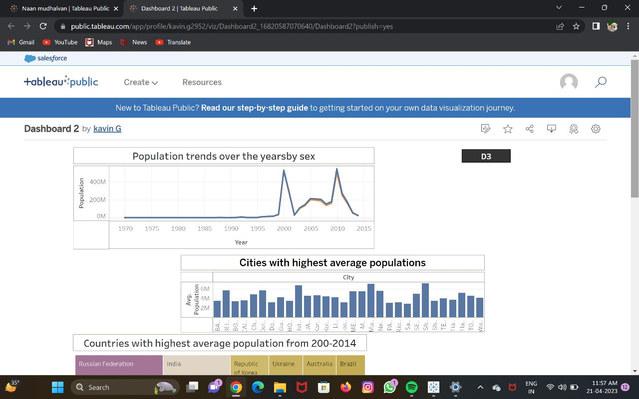

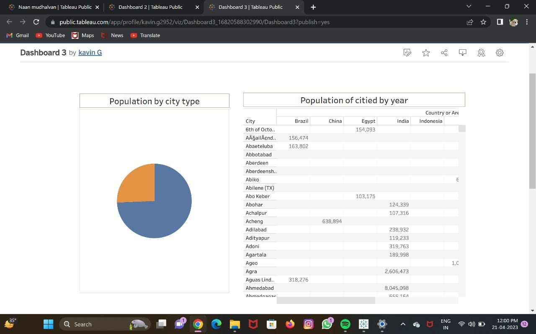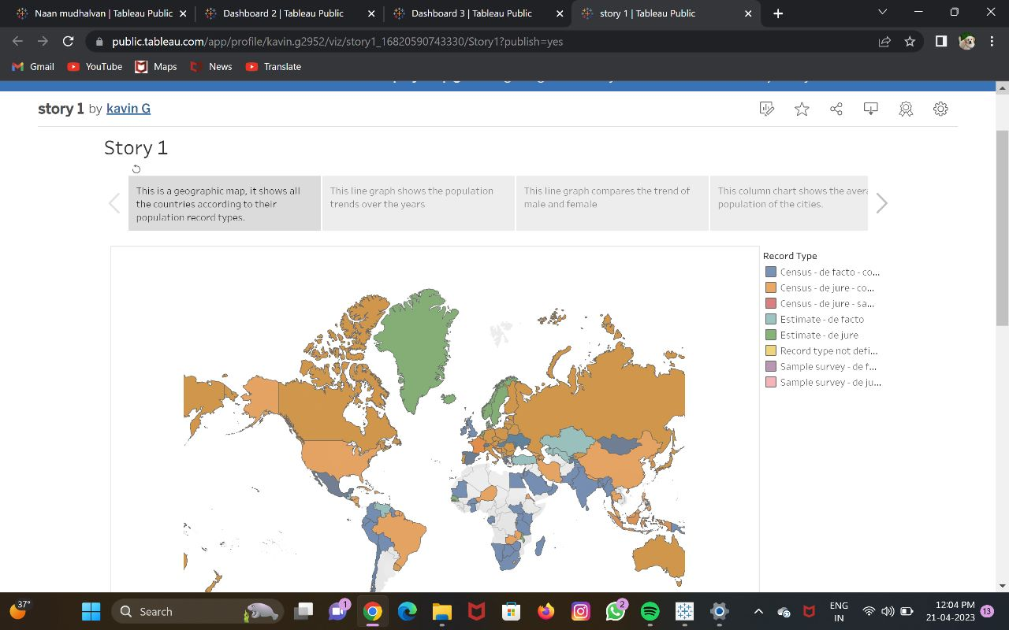

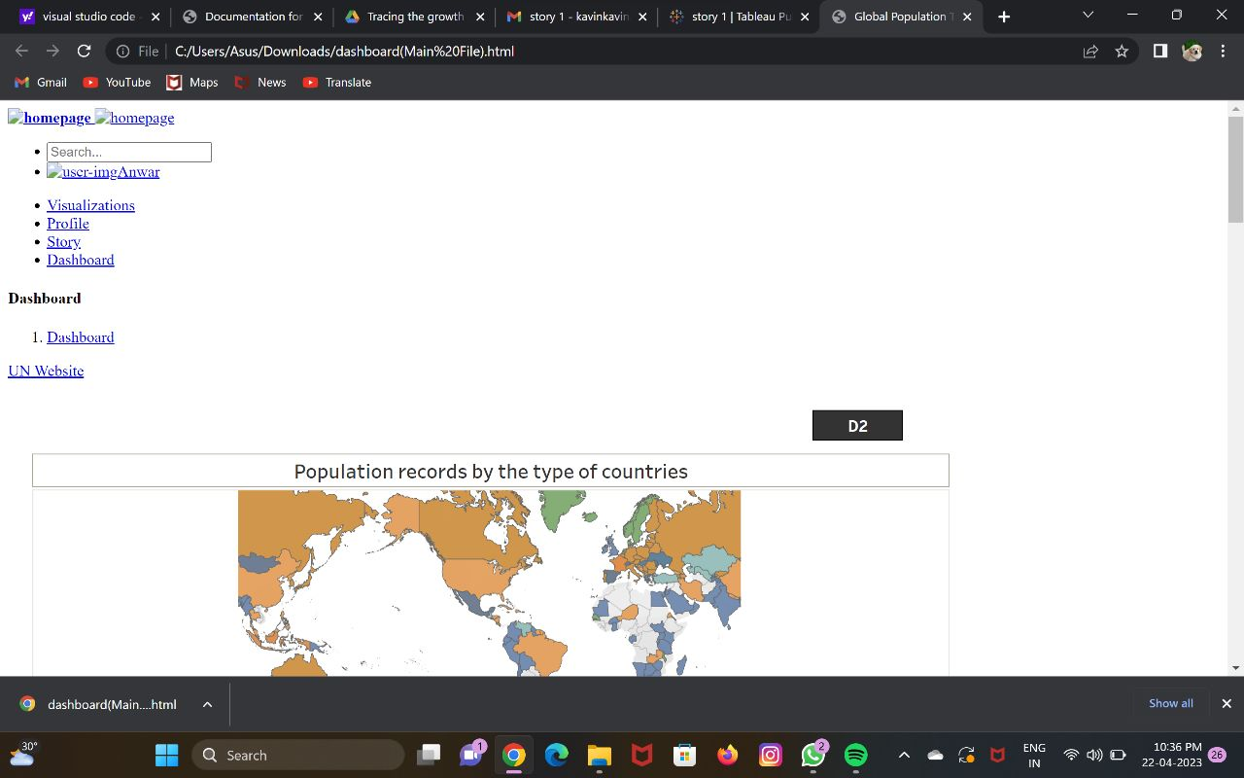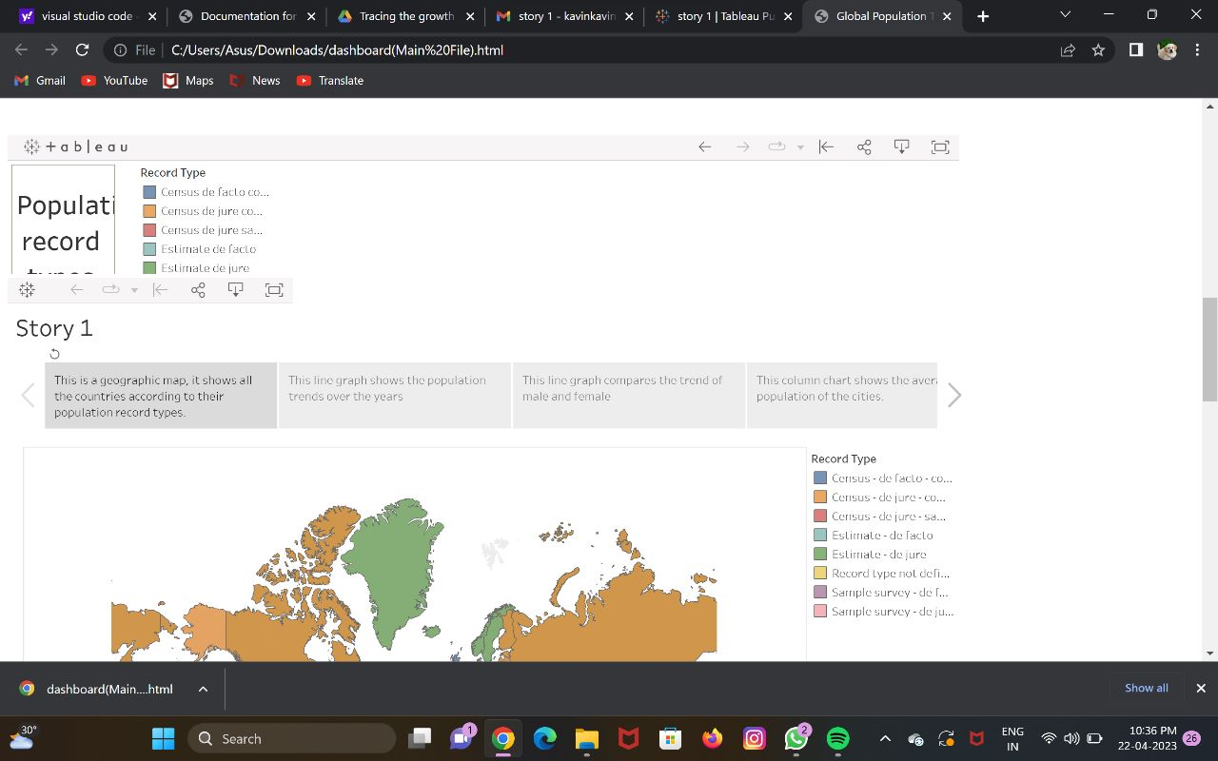

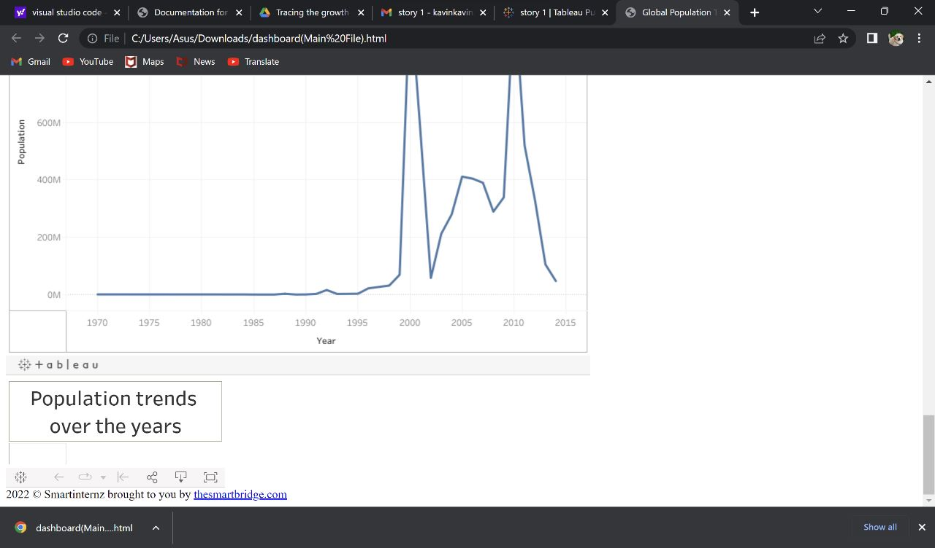

4. ADVANTAGES & DISADVANTAGE

Advantages:

Resource allocation: Population growth data helps governments and organizations allocate resources for housing, healthcare, education, and other public services according to the needs of the population.

Economic growth: Population growth can be an indicator of economic growth and development, as more people create more demand for goods and services.

Social development: Population growth can lead to social development by increasing the labor force, promoting innovation, and increasing the diversity of the population.

Environmental planning: Population growth data can be used to plan for and mitigate the negative impact of population growth on the environment.

Disadvantages:

Resource depletion: Rapid population growth can lead to depletion of natural resources, environmental degradation, and pollution.

Infrastructure overload: High population growth can put stress on existing infrastructure, leading to overcrowding, traffic congestion, and other urban problems.

Social and cultural conflicts: Population growth can lead to social and cultural conflicts due to competition for resources, differences in values and beliefs, and other factors.

Economic disparity: High population growth can exacerbate economic disparity and income inequality, as more people compete for limited job opportunities.

Political instability: Rapid population growth can lead to political instability, as governments struggle to provide services and resources to an expanding population.

5. APPLICATIONS

Resource planning: Understanding the growth rate and demographic characteristics of a population can help with planning for future resource needs, such as housing, healthcare, education, and transportation.

Public policy: The data on population growth can be used to inform public policy decisions related to immigration, family planning, social welfare, and other issues.

Economic development: Population growth can be an important indicator of economic growth and development. By tracking changes in population size and demographics, governments and businesses can anticipate changes in demand for goods and services and adjust their strategies accordingly.

Environmental planning: Population growth can have a significant impact on the environment, particularly in terms of resource depletion and pollution. By monitoring population growth, policymakers and environmentalists can work to mitigate these impacts and promote sustainability.

Health and social services: Understanding population growth and demographics can also help healthcare providers and social service organizations anticipate and meet the needs of their communities. This includes planning for healthcare facilities, social services programs, and other services that may be necessary as the population grows and changes over time.

6. CONCLUSION

In conclusion, tracing the growth of a population can provide valuable insights into the demographic, economic, social, and environmental characteristics of a community. By understanding population growth, governments, organizations, and individuals can make informed decisions about resource allocation, social and economic development, and environmental planning. However, rapid population growth can also have negative consequences, including resource depletion, infrastructure overload, social and cultural conflicts, economic disparity, and political instability. Therefore, it is important to carefully consider the advantages and disadvantages of population growth when making decisions about resource allocation, policy, and planning.

7. FUTURE SCOPE

The future scope for tracing the growth of a population is vast and exciting. Some potential areas for future research and development include:

Data analytics: With the increasing availability of big data, there is a growing opportunity for data scientists to use advanced analytics and machine learning techniques to analyze population growth data and derive insights that can inform policy and decision-making.

Demographic modeling: Advancements in demographic modeling techniques can help researchers better understand the complex relationships between population growth, migration, fertility rates, and other factors that contribute to changes in population size and composition.

Sustainable development: As the global population continues to grow, there is an increasing need for sustainable development practices that balance the needs of people with the protection of natural resources and the environment. Population growth data can help policymakers and planners identify areas of potential conflict and develop solutions that promote sustainability.

Health and wellness: Population growth data can be used to identify trends in health and wellness, including changes in disease prevalence, healthcare access and utilization, and overall quality of life.

Urban planning: As more people move to cities, there is a growing need for urban planners to develop sustainable and livable communities that can accommodate growing populations. Population growth data can help inform decisions about infrastructure development, transportation, and public services that are critical to creating healthy and vibrant cities.

Overall, the future of population growth research is exciting and full of potential for addressing some of the most pressing social, economic, and environmental challenges of our time.

8. Appendix

<!DOCTYPE html>

<html dir="ltr" lang="en">

<head>

    <meta charset="utf-8">

    <meta http-equiv="X-UA-Compatible" content="IE=edge">

    <!-- Tell the browser to be responsive to screen width -->

    <meta name="viewport" content="width=device-width, initial-scale=1">

    <meta name="keywords"

        content="wrappixel, admin dashboard, html css dashboard, web dashboard, bootstrap 5 admin, bootstrap 5, css3 dashboard, bootstrap 5 dashboard, Ample lite admin bootstrap 5 dashboard, frontend, responsive bootstrap 5 admin template, Ample admin lite dashboard bootstrap 5 dashboard template">

    <meta name="description"

        content="Ample Admin Lite is powerful and clean admin dashboard template, inpired from Bootstrap Framework">

    <meta name="robots" content="noindex,nofollow">

    <title>Global Population Timeseries Analysis</title>

    <link rel="canonical" href="https://www.wrappixel.com/templates/ample-admin-lite/" />

    <!-- Favicon icon -->

    <link rel="icon" type="image/png" sizes="16x16" href="plugins/images/favicon.png">

    <!-- Custom CSS -->

    <link href="plugins/bower_components/chartist/dist/chartist.min.css" rel="stylesheet">

    <link rel="stylesheet" href="plugins/bower_components/chartist-plugin-tooltips/dist/chartist-plugin-tooltip.css">

    <!-- Custom CSS -->

    <link href="css/style.min.css" rel="stylesheet">

</head>

<body>

    <!-- ============================================================== -->

    <!-- Preloader - style you can find in spinners.css -->

    <!-- ============================================================== -->

    <div class="preloader">

        <div class="lds-ripple">

            <div class="lds-pos"></div>

            <div class="lds-pos"></div>

        </div>

    </div>

    <!-- ============================================================== -->

    <!-- Main wrapper - style you can find in pages.scss -->

    <!-- ============================================================== -->

    <div id="main-wrapper" data-layout="vertical" data-navbarbg="skin5" data-sidebartype="full"

        data-sidebar-position="absolute" data-header-position="absolute" data-boxed-layout="full">

        <!-- ============================================================== -->

        <!-- Topbar header - style you can find in pages.scss -->

        <!-- ============================================================== -->

        <header class="topbar" data-navbarbg="skin5">

            <nav class="navbar top-navbar navbar-expand-md navbar-dark">

                <div class="navbar-header" data-logobg="skin6">

                    <!-- ============================================================== -->

                    <!-- Logo -->

                    <!-- ============================================================== -->

                    <a class="navbar-brand" href="dashboard.html">

                        <!-- Logo icon -->

                        <b class="logo-icon">

                            <!-- Dark Logo icon -->

                            <img src="plugins/images/logo-icon3.jpg" alt="homepage" />

                        </b>

                        <!--End Logo icon -->

                        <!-- Logo text -->

                        <span class="logo-text">

                            <!-- dark Logo text -->

                            <img src="plugins/images/logo-text5.png" alt="homepage" />

                        </span>

                    </a>

                    <!-- ============================================================== -->

                    <!-- End Logo -->

                    <!-- ============================================================== -->

                    <!-- ============================================================== -->

                    <!-- toggle and nav items -->

                    <!-- ============================================================== -->

                    <a class="nav-toggler waves-effect waves-light text-dark d-block d-md-none"

                        href="javascript:void(0)"><i class="ti-menu ti-close"></i></a>

                </div>

                <!-- ============================================================== -->

                <!-- End Logo -->

                <!-- ============================================================== -->

                <div class="navbar-collapse collapse" id="navbarSupportedContent" data-navbarbg="skin5">

                    <!-- ============================================================== -->

                    <!-- Right side toggle and nav items -->

                    <!-- ============================================================== -->

                    <ul class="navbar-nav ms-auto d-flex align-items-center">

                        <!-- ============================================================== -->

                        <!-- Search -->

                        <!-- ============================================================== -->

                        <li class=" in">

                            <form role="search" class="app-search d-none d-md-block me-3">

                                <input type="text" placeholder="Search..." class="form-control mt-0">

                                <a href="" class="active">

                                    <i class="fa fa-search"></i>

                                </a>

                            </form>

                        </li>

                        <!-- ============================================================== -->

                        <!-- User profile and search -->

                        <!-- ============================================================== -->

                        <li>

                            <a class="profile-pic" href="#">

                                <img src="plugins/images/users/smartinternz_thumb.png" alt="user-img" width="36"

                                    class="img-circle"><span class="text-white font-medium">Anwar</span></a>

                        </li>

                        <!-- ============================================================== -->

                        <!-- User profile and search -->

                        <!-- ============================================================== -->

                    </ul>

                </div>

            </nav>

        </header>

        <!-- ============================================================== -->

        <!-- End Topbar header -->

        <!-- ============================================================== -->

        <!-- ============================================================== -->

        <!-- Left Sidebar - style you can find in sidebar.scss  -->

        <!-- ============================================================== -->

        <aside class="left-sidebar" data-sidebarbg="skin6">

            <!-- Sidebar scroll-->

            <div class="scroll-sidebar">

                <!-- Sidebar navigation-->

                <nav class="sidebar-nav">

                    <ul id="sidebarnav">

                        <!-- User Profile-->

                        <li class="sidebar-item pt-2">

                            <a class="sidebar-link waves-effect waves-dark sidebar-link" href="dashboard.html"

                                aria-expanded="false">

                                <i class="far fa-clock" aria-hidden="true"></i>

                                <span class="hide-menu">Visualizations</span>

                            </a>

                        </li>

                        <li class="sidebar-item">

                            <a class="sidebar-link waves-effect waves-dark sidebar-link" href="profile.html"

                                aria-expanded="false">

                                <i class="fa fa-user" aria-hidden="true"></i>

                                <span class="hide-menu">Profile</span>

                            </a>

                        </li>

                        <li class="sidebar-item">

                            <a class="sidebar-link waves-effect waves-dark sidebar-link" href="story.html"

                                aria-expanded="false">

                                <i class="fa fa-table" aria-hidden="true"></i>

                                <span class="hide-menu">Story</span>

                            </a>

                        </li>

                        <li class="sidebar-item">

                            <a class="sidebar-link waves-effect waves-dark sidebar-link" href="dash1.html"

                                aria-expanded="false">

                                <i class="fa fa-table" aria-hidden="true"></i>

                                <span class="hide-menu">Dashboard</span>

                            </a>

                        </li>

                        <!-- <li class="text-center p-20 upgrade-btn">

                            <a href="https://www.wrappixel.com/templates/ampleadmin/"

                                class="btn d-grid btn-danger text-white" target="_blank">

                                Upgrade to Pro</a>

                        </li> -->

                    </ul>

                </nav>

                <!-- End Sidebar navigation -->

            </div>

            <!-- End Sidebar scroll-->

        </aside>

        <!-- ============================================================== -->

        <!-- End Left Sidebar - style you can find in sidebar.scss  -->

        <!-- ============================================================== -->

        <!-- ============================================================== -->

        <!-- Page wrapper  -->

        <!-- ============================================================== -->

        <div class="page-wrapper">

            <!-- ============================================================== -->

            <!-- Bread crumb and right sidebar toggle -->

            <!-- ============================================================== -->

            <div class="page-breadcrumb bg-white">

                <div class="row align-items-center">

                    <div class="col-lg-3 col-md-4 col-sm-4 col-xs-12">

                        <h4 class="page-title">Dashboard</h4>

                    </div>

                    <div class="col-lg-9 col-sm-8 col-md-8 col-xs-12">

                        <div class="d-md-flex">

                            <ol class="breadcrumb ms-auto">

                                <li><a href="#" class="fw-normal">Dashboard</a></li>

                            </ol>

                            <a href="https://www.un.org/development/desa/pd/" target="_blank"

                                class="btn btn-danger  d-none d-md-block pull-right ms-3 hidden-xs hidden-sm waves-effect waves-light text-white">UN

                                Website</a>

                        </div>

                    </div>

                </div>

                <!-- /.col-lg-12 -->

            </div>

            <!-- ============================================================== -->

            <!-- End Bread crumb and right sidebar toggle -->

            <!-- ============================================================== -->

            <!-- ============================================================== -->

            <!-- Container fluid  -->

            <!-- ============================================================== -->

            <div class="container-fluid">

                <!-- ============================================================== -->

                <!-- Three charts -->

                <!-- ============================================================== -->

                <!-- ============================================================== -->

                <!-- PRODUCTS YEARLY SALES -->

                <!-- ============================================================== -->

                <div <div class='tableauPlaceholder' id='viz1682182396876' style='position: relative'><noscript><a href='#'><img alt='Dashboard 1 ' src='https:&#47;&#47;public.tableau.com&#47;static&#47;images&#47;Na&#47;Naanmudhalvan&#47;Dashboard1&#47;1_rss.png' style='border: none' /></a></noscript><object class='tableauViz'  style='display:none;'><param name='host_url' value='https%3A%2F%2Fpublic.tableau.com%2F' /> <param name='embed_code_version' value='3' /> <param name='site_root' value='' /><param name='name' value='Naanmudhalvan&#47;Dashboard1' /><param name='tabs' value='no' /><param name='toolbar' value='yes' /><param name='static_image' value='https:&#47;&#47;public.tableau.com&#47;static&#47;images&#47;Na&#47;Naanmudhalvan&#47;Dashboard1&#47;1.png' /> <param name='animate_transition' value='yes' /><param name='display_static_image' value='yes' /><param name='display_spinner' value='yes' /><param name='display_overlay' value='yes' /><param name='display_count' value='yes' /><param name='language' value='en-US' /></object></div>                <script type='text/javascript'>                    var divElement = document.getElementById('viz1682182396876');                    var vizElement = divElement.getElementsByTagName('object')[0];                    if ( divElement.offsetWidth > 800 ) { vizElement.style.width='1000px';vizElement.style.height='827px';} else if ( divElement.offsetWidth > 500 ) { vizElement.style.width='1000px';vizElement.style.height='827px';} else { vizElement.style.width='100%';vizElement.style.height='727px';}                     var scriptElement = document.createElement('script');                    scriptElement.src = 'https://public.tableau.com/javascripts/api/viz_v1.js';                    vizElement.parentNode.insertBefore(scriptElement, vizElement);                </script>

                <noscript><a href='#'><img alt='Population record types of countries ' src='https:&#47;&#47;public.tableau.com&#47;static&#47;images&#47;po&#47;population_viz1&#47;Sheet1&#47;1_rss.png' style='border: none' /></a>

                </noscript>

                <object class='tableauViz'  style='display:none;'>

                <param name='host_url' value='https%3A%2F%2Fpublic.tableau.com%2F' />

                <param name='embed_code_version' value='3' />

                 <param name='site_root' value='' />

                 <param name='name' value='population_viz1&#47;Sheet1' />

                 <param name='tabs' value='no' />

                 <param name='toolbar' value='yes' />

                 <param name='static_image' value='https:&#47;&#47;public.tableau.com&#47;static&#47;images&#47;po&#47;population_viz1&#47;Sheet1&#47;1.png' />

                  <param name='animate_transition' value='yes' />

                  <param name='display_static_image' value='yes' />

                  <param name='display_spinner' value='yes' />

                  <param name='display_overlay' value='yes' />

                  <param name='display_count' value='yes' />

                  <param name='language' value='en-US' />

                  <param name='filter' value='publish=yes' />

                  </object></div>

                    <script type='text/javascript'>

                     var divElement = document.getElementById('viz1674235317004');

                       var vizElement = divElement.getElementsByTagName('object')[0];

                        vizElement.style.width='100%';vizElement.style.height=(divElement.offsetWidth*0.75)+'px';                    var scriptElement = document.createElement('script');                    scriptElement.src = 'https://public.tableau.com/javascripts/api/viz_v1.js';

                vizElement.parentNode.insertBefore(scriptElement, vizElement);

                    </script>

                <!-- ============================================================== -->

                <!-- RECENT SALES -->

                <!-- ============================================================== -->

                                <!-- <h3 class="box-title mb-0">Trend</h3> -->

                                <div <div class='tableauPlaceholder' id='viz1682182638061' style='position: relative'><noscript><a href='#'><img alt='Story 1 ' src='https:&#47;&#47;public.tableau.com&#47;static&#47;images&#47;st&#47;story1_16820590743330&#47;Story1&#47;1_rss.png' style='border: none' /></a></noscript><object class='tableauViz'  style='display:none;'><param name='host_url' value='https%3A%2F%2Fpublic.tableau.com%2F' /> <param name='embed_code_version' value='3' /> <param name='site_root' value='' /><param name='name' value='story1_16820590743330&#47;Story1' /><param name='tabs' value='no' /><param name='toolbar' value='yes' /><param name='static_image' value='https:&#47;&#47;public.tableau.com&#47;static&#47;images&#47;st&#47;story1_16820590743330&#47;Story1&#47;1.png' /> <param name='animate_transition' value='yes' /><param name='display_static_image' value='yes' /><param name='display_spinner' value='yes' /><param name='display_overlay' value='yes' /><param name='display_count' value='yes' /><param name='language' value='en-US' /></object></div>                <script type='text/javascript'>                    var divElement = document.getElementById('viz1682182638061');                    var vizElement = divElement.getElementsByTagName('object')[0];                    vizElement.style.width='1016px';vizElement.style.height='991px';                    var scriptElement = document.createElement('script');                    scriptElement.src = 'https://public.tableau.com/javascripts/api/viz_v1.js';                    vizElement.parentNode.insertBefore(scriptElement, vizElement);                </script>

                                    <a href='#'><img alt='Population trends over the years ' src='https:&#47;&#47;public.tableau.com&#47;static&#47;images&#47;po&#47;population_viz2&#47;Sheet2&#47;1_rss.png' style='border: none' /></a></noscript><object class='tableauViz'  style='display:none;'>

                                    <param name='host_url' value='https%3A%2F%2Fpublic.tableau.com%2F' />

                                    <param name='embed_code_version' value='3' />

                                     <param name='site_root' value='' />

                                     <param name='name' value='population_viz2&#47;Sheet2' />

                                     <param name='tabs' value='no' /><param name='toolbar' value='yes' />

                                     <param name='static_image' value='https:&#47;&#47;public.tableau.com&#47;static&#47;images&#47;po&#47;population_viz2&#47;Sheet2&#47;1.png' /> <param name='animate_transition' value='yes' />

                                     <param name='display_static_image' value='yes' />

                                     <param name='display_spinner' value='yes' />

                                     <param name='display_overlay' value='yes' />

                                     <param name='display_count' value='yes' />

                                     <param name='language' value='en-US' />

                                     <param name='filter' value='publish=yes' />

                                     </object></div>

                                     <script type='text/javascript'>

                                         var divElement = document.getElementById('viz1674235531254');

                                              var vizElement = divElement.getElementsByTagName('object')[0];

                                                  vizElement.style.width='100%';vizElement.style.height=(divElement.offsetWidth*0.75)+'px';

                                                       var scriptElement = document.createElement('script');

                                                      scriptElement.src = 'https://public.tableau.com/javascripts/api/viz_v1.js';

                                                              vizElement.parentNode.insertBefore(scriptElement, vizElement);

                                      </script>

                <!-- ============================================================== -->

                <!-- Recent Comments -->

                <!-- ============================================================== -->

            <!-- ============================================================== -->

            <!-- End Container fluid  -->

            <!-- ============================================================== -->

            <!-- ============================================================== -->

            <!-- footer -->

            <!-- ============================================================== -->

            <footer class="footer text-center"> 2022 © Smartinternz brought to you by <a

                    href="https://www.thesmartbridge.com/">thesmartbridge.com</a>

            </footer>

            <!-- ============================================================== -->

            <!-- End footer -->

            <!-- ============================================================== -->

        </div>

        <!-- ============================================================== -->

        <!-- End Page wrapper  -->

        <!-- ============================================================== -->

    </div>

    <!-- ============================================================== -->

    <!-- End Wrapper -->

    <!-- ============================================================== -->

    <!-- ============================================================== -->

    <!-- All Jquery -->

    <!-- ============================================================== -->

    <script src="plugins/bower_components/jquery/dist/jquery.min.js"></script>

    <!-- Bootstrap tether Core JavaScript -->

    <script src="bootstrap/dist/js/bootstrap.bundle.min.js"></script>

    <script src="js/app-style-switcher.js"></script>

    <script src="plugins/bower_components/jquery-sparkline/jquery.sparkline.min.js"></script>

    <!--Wave Effects -->

    <script src="js/waves.js"></script>

    <!--Menu sidebar -->

    <script src="js/sidebarmenu.js"></script>

    <!--Custom JavaScript -->

    <script src="js/custom.js"></script>

    <!--This page JavaScript -->

    <!--chartis chart-->

    <script src="plugins/bower_components/chartist/dist/chartist.min.js"></script>

    <script src="plugins/bower_components/chartist-plugin-tooltips/dist/chartist-plugin-tooltip.min.js"></script>

    <script src="js/pages/dashboards/dashboard1.js"></script>

</body>

</html>